Mixed Methods Research Caribbean Chapter
Season Greetings and Report from Chair:
December 30, 2017

Dear Members and Friends,
This has been an interesting and exciting year, when the Mixed Methods Research Caribbean Chapter (MMRCC) was launched in March 2017 at our Second Regional Conference in Montego Bay. To all our members thanks for your support over the year 2017 and we wish for you a productive 2018.
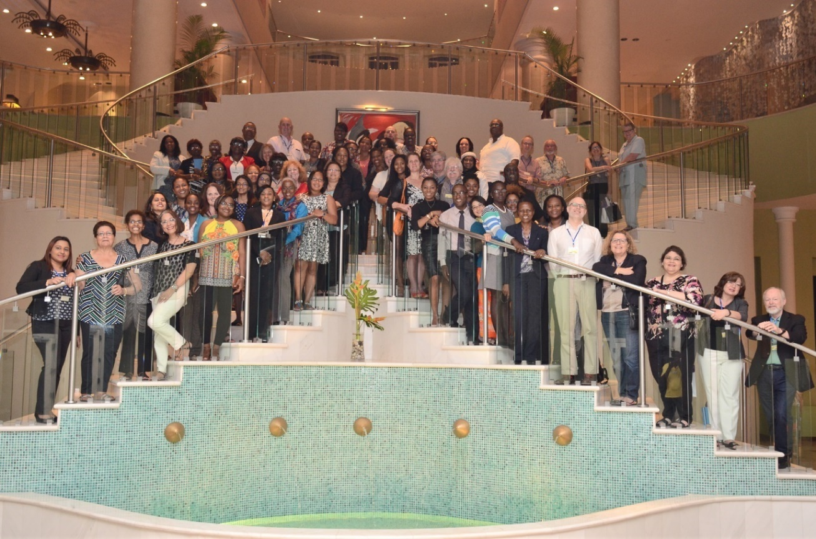
[Present at the launch were members of the MMIRA executive team including the then President, Professor Tony Onwuegbuzie; Treasurer, Dr.Antigoni Papadimitriou; Membership Committee Chair, John Hitchcock; Conference Committee Chair, Kathy Collins; Associate editor of the Journal of Mixed Methods Research, Professor Jennifer Greene; the first President and Founding member Professor John Creswell; Co-Director, Michigan Mixed Methods Research and Scholarship Program and Co- Editor of the Journal of Mixed Methods Research, Professor Michael Fetters, Co-editor of SAGE's Mixed Methods Research Series, Professor Nataliya Ivankova; and Dr. Cindy Benge (MMIRA). Also present was Dr. Normand Peladeau (Developer of Prosuite – Software for Mixing Qualitative and Quantitative Data Analysis)].

Since March 2017, we had our inaugural members’ meeting on November 21, 2017 at 100 Hope Road Restaurant, Kingston. In attendance were approximately 30 MMRCC members. This event took the form of a business cocktail. Members and guests were provided with the following updates:

- Our progress in formalizing the Chapter as a legal entity in the Caribbean and details on the benefits of Chapter membership.

- Mrs. Tashane Haynes Brown and Ms. Leemoy Weaver gave brief presentations on their participation in Mixed Methods Research workshops at the University of Michigan.
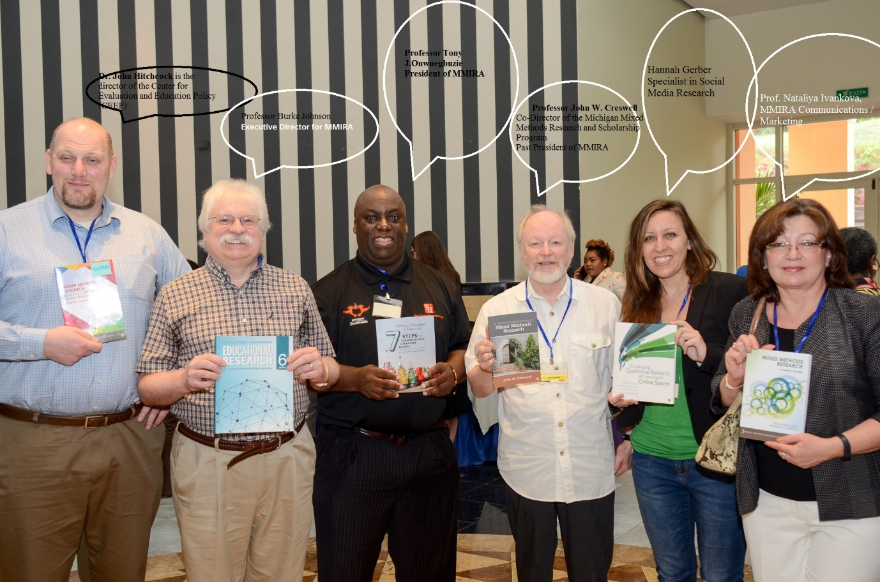
MMIRA Representatives with Samples of their Publications

At the inaugural function, the executive committee was also presented. Please see attached details of the executive committee and board of directors. We are seeking volunteers for each of the following:
- Governance Committee
- Membership Committee
- Conference Committee
- Communications and Marketing Committee
- A webmaster

We are very grateful to Ms. Loreen Walker (Associate University Counsel) for her gratuitous service in establishing the Chapter as a legal entity. The membership fees will be used to finance the registration fees for the abovementioned process.
We thank Professor Dale Webber (Pro-Vice-Chancellor, Graduate Studies and Research and Professor. Eldemire Shearer for their commitment and support. Special thanks to Professor Tony Onwuegbuzie (immediate past president of the MMIRA), Professor Burke Johnson (immediate past Executive Director) and Professor John Hitchcook and Dr. Cindy Benge for their support and commitment on the journey to becoming a Chapter of the MMIRA. We look forward to working with and continued support from the MMIRA President Professor Cheryl Poth.

The following are our own Caribbean colleagues who have worked tirelessly to get us to this point:
- Dr. Laila Boisselle (Trinidad)
- Dr. Vimala Kamalodeen (Trinidad)
- Dr. Claudette FongKong Mungal (Barbados)
From Jamaica are the following persons:
- Mr. Stanford Moore
- Prof. Denise Eldemire-Shearer
- Prof. Hopeton Dunn
- Dr. Steve Weaver
- Dr. Lloyd Waller
- Mrs. Tashane Haynes Brown
- Mrs. Avalloy McCarthy Curvin
- Ms. LeemoyWeaver
- Mr. Rohan McCalla
- Dr. Ingrid Anderson
- Mrs. Karen Thwaites
- Mrs. Clavia Williams
- Ms. Olivene Thomas
- Dr. Livingston White
- Mrs. Marcia Philipps
- Ms. Nadine Davis
- Mr. James Lattibeaudiere
Special thanks to School of Education’s immediate past director Professor Stafford Griffith for his support.

Please find attached the following:
- A copy of the invitation letter to the Inaugural Dinner , and
- Details on the benefits of Chapter membership

We wish you a prosperous and productive New Year, 2018

Yours truly,
Loraine D. Cook, PhD
MMRCC Chair

